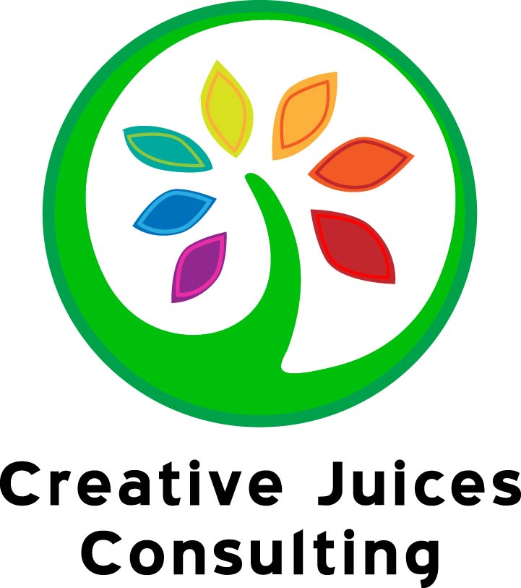 Book Recommendations
- Foods To Fight Cancer by Richard Beliveau
- Breast Cancer: Reduce your Risk With Foods You Love by Robert Pendergrast
- Integrative Oncology eds Donald Abrams and Andrew Weil
- Anticancer: A new way of lift by David Servan-Schreiber
- Life Over Cancer by Keith Block
- The Definitive Guide to Cancer by Lise Alshuler and Karolyn Gazella
- The Omnivore’s Dilemma by Michael Pollan
- In Defense of Food by Michael Pollan
- Animal, Vegetable, Miracle by Barbara Kingsolver
- Integrative Nutrition by Joshua Rosenthal
- Crazy Sexy Cancer by Kris Carr
- Super Immunity by Joel Fuhrman
- The Cancer-Fighting Kitchen by Rebecca Katz with Mat Edelson
- Eating Well for Optimum Health by Andrew Weil
- What to Eat If You Have Cancer: Healing Foods that Boost Your Immune System – Daniella Chace and Maureen Keane, MS
Nutrition & Wellness Resources
- Windriverservices.org & Creativejuicesconsulting.com
- Cancerdietitian.com Julie Lanford MPH, RD, CSO, LDN, is the Wellness Director for Cancer Services, a non-profit in Winston-Salem, NC. She is a registered dietitian, licensed nutritionist and a board certified specialist in oncology nutrition.
- AICR (American Institute for Cancer Research)Nutrition Hotline - 800.843.8114
- AICR.org H.E.A.L. Well (Healthy Eating and Activity for Living) A Cancer Nutrition Guide was created through a joint project of the American Institute for Cancer Research (AICR), the LIVESTRONG Foundation, and Meals to Heal™. Provides general information regarding nutrition and cancer, addresses common questions people have about diet, nutrition, and physical activity during and after cancer treatment, and offers suggestions for common cancer or cancer treatment-related symptom management.
- Cureconnections.curetoday.com Offering videos on a variety of topics including nutrition tips and recipes.
- Smithcenter.org Health , education & arts organization for integrative resources
- Ewg.org (Environmental Working Group) Publishes the "Dirty Dozen" list of top foods to buy organic each year
- Fivetothriveplan.com An integrative approach to cancer prevention created by Dr. Lise Alschuler and Karolyn A. Gazella that features an informational website, books, radio show, videos, social networks, and a digital magazine.
- Eatright.org Acadamy of Nutrition and Dietetics
- fnic.nal.usda.gov The Food and Nutrition Information Center (FNIC) is a leader in on-line global nutrition information. The FNIC Web site contains over 2500 links to current and reliable nutrition information.
- http://www.drweil.com The anti-inflammatory food pyramid
- http://drhyman.com Alternative food pyramid incorporating gluten-free grains and lean animal protein

